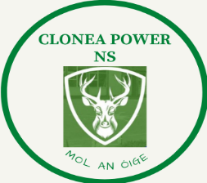
CLONEA POWER NS
ANNUAL ADMISSION NOTICE
in respect of admissions to the 2023/2024 school year

Admission Policy and Application Form
A copy of the school’s Admission Policy and the Application Form for Admission for Clonea Power NS is available as follows: –
To download at: www.cloneapowerschool.ie
On request: By emailing info@cloneapowerschool.ie
or writing to:
Clonea Power NS, Clonea Power, Carrick on Suir, Co. Waterford, E32NP40
or telephoning:
051646249

Admissions to the 2023/2024 school year

Application and Decision Dates for admission to 2023/2024 School Year
The following are the dates applicable for admission to Junior Infants

The school will commence accepting applications for admission on | 3rd October 2022
The school shall cease accepting applications for admission on | 1st March 2023
The date by which applicants will be notified of the decision on their application is | 15th March 2023
The period within which applicants must confirm acceptance of an offer of admission is | 2 weeks
*Failure to accept an offer within the prescribed period above may result in the offer being withdrawn

Note: the school will consider and issue decisions on late applications in accordance with the school’s admission policy.

Number of places being made available in 2022/2023 school year

The number of places being made available in junior infants is | 25

