CLONEA POWER SCHOOL HOLIDAYS 2023 / 2024
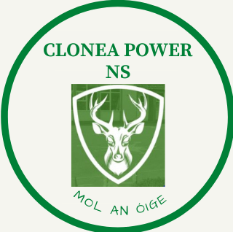

First Day of Term: Thursday, 31st August, 2023

Mid Term Break: School Closes: Friday, 27th October, 2023
School Re opens: Monday, 6th November, 2023

Christmas Holidays: School Closes 12 noon Friday, 22nd December, 2023
School Re Opens Monday, 8th January, 2024

St.Bridget’s Day: Monday, 5th February, 2024

Mid Term Break: Thursday, 15th February, 2024
Friday, 16th February, 2024

St.Patrick’s Day: Closed Monday, 18th March, 2024

Easter Holidays: School closes 12 noon Friday, 22nd March, 2024
School Re opens Monday, 5th April, 2024

May Bank Holiday: Closed Monday, 8th May, 2024 and
Tuesday, 9th May, 2023
June Bank Holiday: Closed Monday, 3rd June, 2024 and
Tuesday, 4th June, 2024

Last Day of Term: School closes at 12 noon Wednesday, 26th June, 2024

