Clonea Power NS

DATA PROTECTION POLICY

Introduction:
This policy was formulated by the Staff and Board of Management of Clonea Power National School. The purpose of the policy is to identify the records required to be retained by the school and to ensure confidentiality and manageable procedures in relation to access to such records by parents and stakeholders. The policy emphasises transparency, security and accountability by BOM as data controller and school staff as data processors, while at the same time standardising the right of individuals to data privacy.

Rationale:
- A policy on data protection and record keeping is necessary to ensure that the school has proper procedures in place in relation to accountability and transparency
- It is good practice to record pupil progress so as to identify learning needs
- A policy must be put in place to ensure a school complies with legislation such as:
- European Union General Data Protection Regulations
- Education Act, Section 9g requiring a school to provide access to records to students over 18/parents
- Education Welfare Act 2000 – requiring a school to report school attendance and transfer of pupils.
- Under Section 20 of the Education (Welfare) Act, 2000, the school must maintain a register of all students attending the School
- Under Section 20(5) of the Education (Welfare) Act, 2000, a principal is obliged to notify certain information relating to the child’s educational progress to the principal of another school to which a student is transferring
- Under Section 21 of the Education (Welfare) Act, 2000, the school must record the attendance or non-attendance of students registered at the school on each day
- Under Section 28 of the Education (Welfare) Act, 2000, the school may supply Personal Data kept by it to certain prescribed bodies (the Department of Education and Skills, the National Education Welfare Board, the National Council for Special Education, other schools, other centres of education) provided the school is satisfied that it will be used for a “relevant purpose” (which includes recording a person’s educational or training history or monitoring their educational progress in order to ascertain how best they may be assisted in availing of educational or training opportunities or in developing their educational potential; or for carrying out research into examinations, participation in education and the general effectiveness of education or training)
- Under Section 14 of the Education for persons with Special Educational Needs Act, 2004, the school is required to furnish to the National Council for Special Education and its employees, which would include Special Educational Needs Organisers (“SENOs”) such information as the Council may from time to time reasonably request.
- The Freedom of Information Act 1997 provides a qualified right to access to information held by public bodies which does not necessarily have to be “personal data” as with data protection legislation. While schools are not currently subject to freedom of information legislation, if a school has furnished information to a body covered by the Freedom of Information Act (such as the Department of Education and Skills, etc.) these records could be disclosed if a request is made to that body.
- Under Section 26(4) of the Health Act, 1947 a school shall cause all reasonable facilities (including facilities for obtaining names and addresses of pupils attending the school) to be given to a health authority who has served a notice on it of medical inspection, e.g. a dental inspection
- Under Children First: National Guidance for the Protection and Welfare of Children (2011) published by the Department of Children and Youth Affairs, schools, their boards of management and their staff have responsibilities to report child abuse or neglect to TUSLA – Child and Family Agency (or in the event of an emergency and the unavailability of TUSLA, to An Garda Síochána).

Relationship to School Ethos:
Clonea Power NS promotes openness and co-operation between staff, parents and pupils as a means towards providing the caring environment through which a child can develop and grow to his full potential.

Aims/Objectives:
- To ensure the school complies with legislative requirements
- Ensure information is obtained and processed fairly
- To clarify the types of records maintained and the procedures relating to making them available to the relevant bodies
- To maintain proper recording and reporting framework on the educational progress of pupils
- To provide clear guidelines on making these records available to parents and past pupils who are over 18
- To stipulate the length of time records and reports will be retained.

The Eight Rules of Data Protection
  - Obtain and process information fairly.
  - Keep it only for one or more specified, explicit and lawful purposes.
  - Use and disclose it only in ways compatible with these purposes.
  - Keep it safe and secure.
  - Keep it accurate, complete and up to date.
  - Ensure that it is adequate, relevant and not excessive.
  - Retain the information for no longer than is necessary.
  - Give a copy of his/her personal data to that individual on request.

Scope
Data
Data is information collected in a form that can be processed. For the purposes of this policy, it includes automated data (information on computer or information recorded with the intention of putting it on a computer) and manual data (information that is kept as part of a relevant filing system or with the intention that it should form part of a filing system).
Relevant Filing System
This refers to any set of information that, while not computerised, is structured by reference to pupils, staff or partners with whom the school has business, so that specific information relating to a particular individual is readily accessible
Personal Data
This refers to data belonging to an individual who is identifiable by this data or from any other personal data that is in possession of the Data Protection Officer.
Data Protection Officer
A data Protection Officer is the individual or staff which controls the contents and use of personal data. The school Board of Management can be considered the Data Controller, with the Principal acting on behalf of the Board of Management in exercising the functions of Data Protection Officer.
Guidelines:
The Principal assumes the function of Data Protection officer for BOM data controller and supervises the application of the Data Protection Act within the school. The data under the control of the Principal comes under the following headings.

  - Personal Data:
This data relates to personal details of the students such as name, address, DOB, gender, ethnic origin, nationality, religious belief, medical details, dietary information, PPSN, contact details and parents’ names. Parents/Guardians reserve the right not to disclose details related to ethnic origin/ background or religious beliefs. These records are retained in both manual form in a locked press in the Oifig an Rúnaí and in electronic form on the school database which is currently Aladdin.

  - Student Records:
Student records are held by each class teacher. Copies of end of year reports and standardized test scores are kept in the office. A computerised school database is also used. Copies of psychological reports, educational assessments etc. are kept in a locked filing cabinet in the deputy principals (SET coordinator) room.

  - Location:
In a secure, locked filing cabinet in the office accessible only to authorised personnel. All staff are required to maintain the confidentiality of any data to which they have access.
  - Security
Format in which these records are kept include both manual records (personal file within a relevant filing system) and computer record (database). Manual records are stored in locked filing cabinets in the office; all computers are password protected and have adequate firewall software.

Student records maintained:
- School report booklets: An annual report is issued to each child’s parent/guardian in June each year. A copy of this report is available on request to a parent who resides at a different address. These booklets are securely stored in the office and on the Aladdin School System.
- Psychological/Clinical/Occupational Therapy/Speech and Language Assessments: Reports are issued following assessment; these are stored in a locked filing cabinet in the deputy principals (SET) room.
- Standardised Test Results: Standardised tests in English and Mathematics are administered in May/June to all classes from First to Sixth class. Class record sheets are securely stored by the class teacher and learning support teachers. Standardised test results are included in the pupil profile sheets.
- Attendance Records: Attendance is recorded online using Aladdin. These computerised records are securely stored in a password protected database.
- Screening Test such as MIST and NRIT: The MIST is administered to all Senior Infant children each year. Class record sheets are securely stored by the class teacher and SET teacher. The principal will also retain a copy of the class record sheet.
- Teacher designed tests: Each class teacher designs his/her own test template, the results of which are stored securely by the teacher.
- Diagnostic Tests Reports: Diagnostic tests are administered by the Deputy Principal (SET Teacher). Results from these assessments are securely stored by the relevant details.
- Student Support Plans: These files are stored securely in a locked filing cabinet by the Deputy Principal in her office and each class teacher will retain a copy. These will also be stored under restricted access on the Aladdin Schools System.
- SET - Learning Support/Resource Data such as records of permission/refusal to access LS/RT services in the school are stored securely in the Deputy Principals room.
- Record of child’s breaches of Code of Behaviour: Incidents of misbehaviour in the school yard are noted in the yard book for each section – Infants, 1st, 2nd & 3rd and 4th, 5th & 6th by the teacher on yard duty. Each class teacher keeps a record of classroom incidents. The deputy/principal maintains a record of incidents brought to her/his attention.
- Records of serious injuries/accidents: The accident report book is securely stored in the main office. The teacher in charge records details of accidents and injuries sustained and actions taken.
- Indemnity form for administration of medicine: These forms are retained in the office and copies scanned on the Aladdin School System.
- Certificates of Exemption from the study of Irish: Copies of certificates are securely stored by the Principal and/or Deputy Principal. These will be stored on Aladdin and password protected.
- Acceptable use policy: These parental consent forms grant children access to the internet while in school and also give parental consent for the child’s photograph to be used on the school website, social media or in the media without naming the child. These forms are kept securely in the office, and are updated annually.

- Staff Data
This data relates to personal and professional details of the Staff such as name, address, date of birth, contact details, payroll number, teaching council number, attendance records, qualifications, Garda vetting, medical fitness to teach, school records, sick leave, CPD, curriculum vitae, school returns, classes taught, seniority and supervision payments. Access to these is restricted to the principal and secretary. Records are destroyed by way of shredding when no longer required.

- Administrative Data:
- Attendance Reports, Roll Book, Registers
- Accident Report Book
- Administration of Medicines Indemnity Form
- Policies
- HSE files
- Board of Management files
- Accounts
- Creditors

Categories of data: The school may hold some or all of the following information about creditors (some of whom are self-employed individuals):
- Name
- Address
- Contact details
- PPS Number
- Tax details
- Bank details
- Amount paid

Purposes: The information is required for routine management and administration of the school’s financial affairs, including the payment of invoices, the compiling of annual financial accounts and complying with audits and investigations by the Revenue Commissioners

Location: In a secure, locked filing cabinet that only personnel who are authorised to use the data can access. The administrative staff are required to maintain the confidentiality of any data to which they have access.

Security: Both manual records (personal file within a relevant filing system) and computer records (database) are kept. Manual records are stored in locked filing cabinets; all computers are password protected and have adequate firewall software.

Guidance for Parents/Guardians at School Events

This section of the policy applies to all video or audio capture of staff and pupils, both in and out of school. It applies to sporting events, parents’ evenings, plays, assemblies, school trips and any other school event or gathering, whether on school premises or beyond.

In Clonea Power NS we appreciate that families treasure photographic/video memories.
However please ensure the following:

- Parents and guardians may take photos and videos of the children in their care, for personal use only.
- When you capture footage or still images of your children, there is a strong possibility that other children will also be visible or audible. For this reason, no such content should be shared publicly.
- Live streaming, whether public or private, is not permitted.
- We request that you do not use any streaming platforms or ‘live’ features (e.g. Facebook Live) to stream school concerts or other school events as they occur.
- You will be asked to leave the school premises or event if this takes place.
- Where possible, we will take appropriate staged group shots/video footage of pupils whose parents/carers have given appropriate photographic permission (Acceptable Use Policy Agreement) and make these available to you on the school website.

The BOM must report to the Data Protection Commission if they become aware that any photos/ or video footage from school concerts/ events have been uploaded and shared publicly on social media.

Access to Records:
- The following will have access where relevant and appropriate to the data listed above;
- Parents/guardians – see Appendix 1 from CPSMA outlining details of access
- Past pupils over 18
- Health Service Executive
- Designated school personnel
- Department of Education & Skills
- First and second-level schools (where relevant).

A parental authorisation form must be completed by parents in the event of data being transferred to outside agencies such as health professionals etc. Outside agencies requesting access to records must do so in writing giving seven days’ notice. The right to erasure or rectification is available to change any mistakes or inaccuracies by proper authorisation through the same procedures.

Storage:
See table below. All records initially contained in locked cabinets in the office and thereafter in archive cabinet. Access to computerised records are password protected.
- All staff data is stored as per Appendix 1.
- All other data is stored in line with departmental guidelines;
- A pupil profile and selection of records are held by each teacher in his/her individual classroom and passed onto the next teacher as the child moves to the next class.
- All waste paper /printouts are destroyed before disposal;
- Access to these stored files is restricted to authorized personnel only.
- NB: Please refer to Appendix 1 for more detailed information re: Recommendations regarding Safe storage and retention periods for different information.

Pupil-related | Retention periods
School register / roll books  Enrolment forms  Disciplinary notes  Test results – standardised Psychological assessments etc.  SEN files/IEPs  Accident reports  Child protection reports/ records | Indefinitely  Hold until pupil is 25 years  Never destroy  Hold until pupil is 25 years  Never destroy  Never destroy  Never destroy  Never destroy  Never destroy
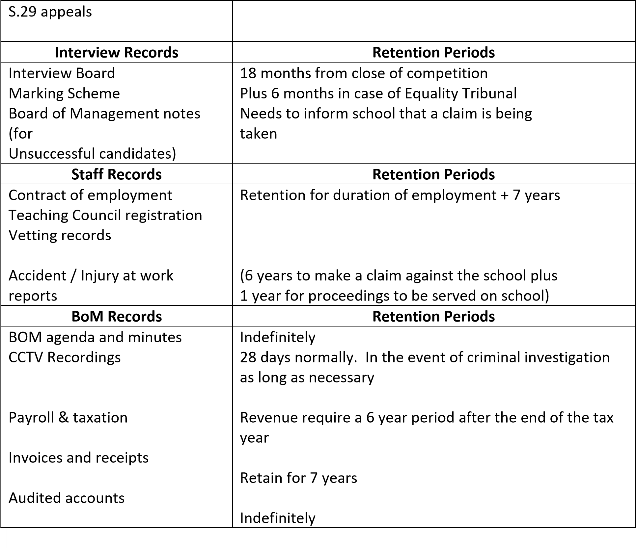

A pupil profile and selection of records are held by each teacher in his/her individual classroom and passed onto the next teacher as the child moves to the next class.

Portfolios of children’s work and pupil profiles. All class and resource rooms and school offices are equipped with lockable cabinets or presses. Access to these stored files is restricted to authorised personnel only.

Electronic Data Storage
The school’s database will be hosted off the premises by a contracted third-party (currently Aladdin).
A limited set of electronic records will be held in the school.
The storage appliances for these records will be secured in the building and the storage media encrypted. Backups will be made to an off-site (cloud-based) provider. These backups will be encrypted in transit (over the internet to the provider) and at rest (stored on the provider’s appliances).
Data Breach Reporting
Any breach of the school’s data protection policies and procedures will result in an investigation by the Board of Management.
If the breach results in the loss or leakage of personal data it will be reported to the Office of the Data Protection Commissioner within 72 hours, even if the investigation is not yet complete.
Breaches that are likely to bring harm to an individual – such as identity theft or breach of confidentiality – will also be notified directly to the individuals concerned.

Consent for Photographs
On enrolment, written consent from parents for pupils to appear in photographs taken at school events with the possibility they may appear on social media is sought. The consent may be withdrawn at any time by notifying the Board of Management in writing.

Links to other policies and curriculum delivery
Our school policies are consistent with one another, within the framework of the overall school plan. Relevant school policies already in place or being developed or reviewed, shall be examined with reference to the data protection policy and any implications which it has for them are addressed.

The following policies are cross referenced:

- Child Protection Policy
- Anti-bullying Policy
- Code of Behaviour
- Admissions Policy
- Substance Use Policy
- ICT Acceptable Usage Policy
- SPHE Policy.

Processing in line with data subject’s rights
Data in this school will be processed in line with the data subjects’ rights
Data subjects have a right to:
- Request access to any data held about them by a data controller
- Prevent the processing of their data for direct-marketing purposes
- Ask to have inaccurate data amended
- Prevent processing that is likely to cause damage or distress to themselves or anyone else

Dealing with data access requests
Under Section 3 of the Data Protection Acts, an individual has the right to be informed whether the school holds data/information about them and to be given a description of the data together with details of the purposes for which their data is being kept. The individual must make this request in writing and the data controller will accede to the request within 21 days.

The right under Section 3 must be distinguished from the much broader right contained in Section 4, where individuals are entitled to a copy of their data.

Section 4 request.

- Individuals are entitled to a copy of their personal data on written request.
- The individual is entitled to a copy of their personal data (subject to some exemptions and prohibitions set down in Section 5 of the Data Protection Act). Request must be responded to within 40 days
- Where a subsequent or similar request is made soon after a request has just been dealt with, it is at the discretion of the school as data controller to comply with the second request (no time limit but reasonable interval from the date of compliance with the last access request.) This will be determined on a case-by-case basis.
- No personal data can be supplied relating to another individual unless that third party has consented to the disclosure of their data to the applicant.
- Data will be carefully redacted to omit references to any other individual and only where it has not been possible to redact the data to ensure that the third party is not identifiable would the school refuse to furnish the data to the applicant.

Providing information over the phone.
In our school, all staff dealing with telephone enquiries are vigilant in not disclosing any personal information held by the school over the phone.
In particular the staff:
- Check the identity of the caller to ensure that information is only given to a person who is entitled to that information.
- Suggest that the caller put their request in writing if the employee is not sure about the identity of the caller and in circumstances where the identity of the caller cannot be verified.
- Refer the request to the principal for assistance in difficult situations. No employee should feel forced into disclosing personal information.

Success Criteria:
- Compliance with Data Protection Act and Statute of Limitations Act
- Easy access to records
- Framework in place for ease of compilation and reporting
- Manageable storage of records.

Implementation arrangements, roles and responsibilities
In our school the Board of Management is the data controller and the principal is assigned the role of coordinating implementation of this Data Protection Policy and for ensuring that staff who handle or have access to Personal Data are familiar with their data protection responsibilities.

The following personnel have responsibility for implementing the Data Protection Policy:

Name Responsibility
Board of Management Data Controller
Principal Data Protection Officer
Teaching personnel Awareness of responsibilities
Administrative personnel Security, confidentiality
IT Personnel Security, encryption, confidentiality

Monitoring the implementation of the policy
The implementation of the policy shall be monitored by the principal and the Board of Management.

Review

- The policy will be reviewed and evaluated every two years and as necessary. On-going review and evaluation should take cognisance of changing information or guidelines (e.g. from the Data Protection Commissioner, Department of Education and Skills or the NEWB), legislation and feedback from parents/guardians, students, school staff and others.
- The policy is revised as necessary in the light of such review and evaluation and within the framework of school planning.

Ratification and Communication
The most recent update of this policy was on December 15th, 2022. A copy of this policy will be made available to each member of staff and each parent through the school website.

The Board of Management of Clonea Power N.S. reserves the right, in consultation with the education partners to review and modify the Data Protection Policy as necessary.

Signed: Catherine Power Martin Whelan
Catherine Power Martin Whelan
Chairperson Principal

Date: 15/12/2022 15/12/2022

